# **E-TICKET MANAGEMENT SYSTEM**

Use-case diagram:

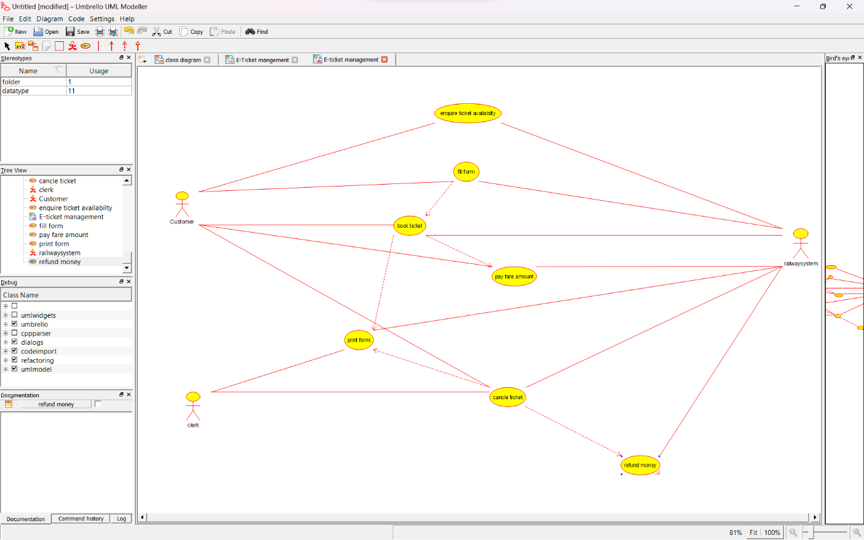

Class Diagram:

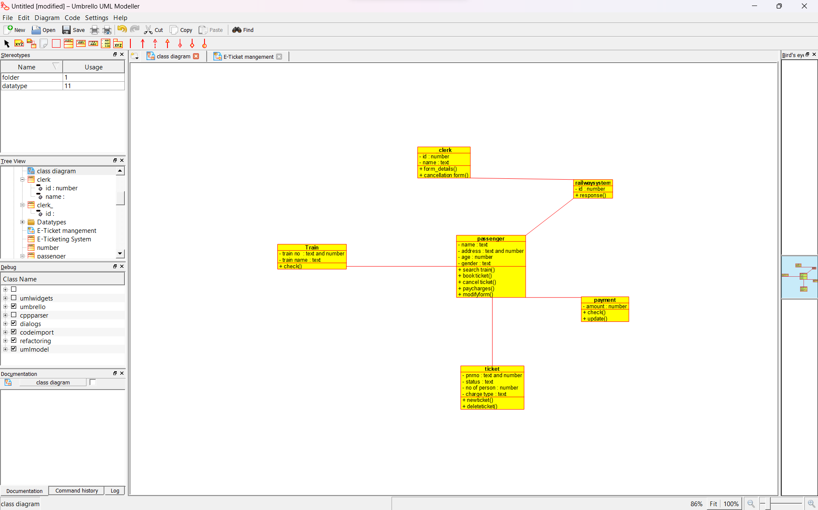

Activity Diagram:

